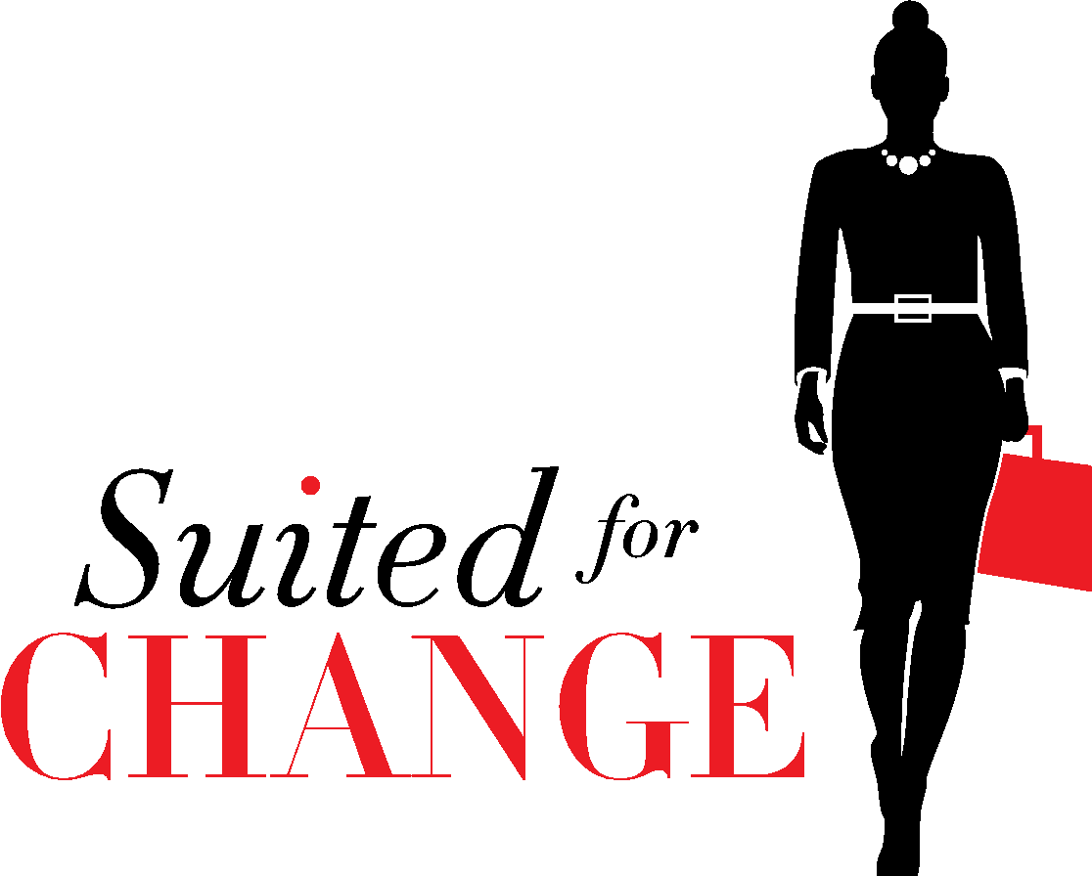
Suited for Change 2023 Gala

IN-KIND DONATION FORM

On Wednesday, May 31st, 2023, Suited for Change will host our annual gala marking 31 successful years of service in the DC area. Suited to Celebrate will be held at District Winery, 285 Water Street, SE Washington, DC. Suited for Change is the region’s leading nonprofit serving women in need of professional attire. Our commitment is to prepare our clients for job interviews and employment. Seven out of ten of the women we serve are heads of households, determined to come out of poverty.
We are seeking in-kind donations for the silent and live auction portions of our gala, which is the most significant fundraising event of SFC’s year. Your support will help ensure that we can continue to benefit the neediest women in our community in strengthening their employment potential.

Name and Description of Item or Service:
__________

Fair Market Value: $

Expiration Date, if any:

If the item is not delivered at the time of completing this form, please select one:
□ This form serves as gift certificate/voucher
□ Item will be delivered via mail (send to: Suited for Change, 1023 15th St, NW, Ste. 601, Washington, DC 20005)
□ Item will be emailed (send to: events@suitedforchange.org)
□ Item will be delivered to SFC in the next few weeks.

Donor Contact Information:

Name: ______

Business Name:

Address: ____________

____________

Telephone: _____________

Email: ___________________

Signature: ______

Date:

Thank you for your generous support. Your donation is tax-deductible to the extent allowable by law. Our federal tax-exempt ID is 52-1790581. A written acknowledgment of your contribution will be sent to you after the event.

